BT-Gen: A Scalable Big Trajectory Generator

USER’S Manual

Data science lab

2019

Table of Contents

1 General Information 3

1.1 System Overview 3

1.2 Organization of the Manual 3

2 System Summary 3

2.1 System Requirements 3

2.1.1 Hardware Requirements 3

2.1.2 Software Requirements 3

3 Getting Started 4

3.1 System Installation 4

4 Using the System 4

4.1 File Management 4

4.2 Trajectory Data Generation 5

4.3 Trajectory Visualization 7

Table of Figures

Figure 1 Database Creation 4

Figure 2 Add Extension 4

Figure 3 Floor Plan Loader 5

Figure 4 Floor Plan Visualization 5

Figure 5 Device Configuration 6

Figure 6 Example of Moving Object Configuration File 6

Figure 7 Moving Object Configuration 7

Figure 8 Trajectory Visualization 7

# General Information

## System Overview

BT-Gen is a trajectory generator that provides large scale generation. This application can read Digital Building Information (DBI) and use for data generation. BT-Gen also provide data visualization for validation purpose.

## Organization of the Manual

This user manual consists of in four sections: General Information, System Summary, Getting Started, and Using the System.

General Information section explain in general terms the system and the purpose for which it is intended.

System Summary section provides a general overview of the system. The summary outlines the uses of the system’s hardware and software requirements, system’s configuration and user access levels.

Getting Started section explains how to install BT-Gen on the device. The section presents briefly system menu.

Using the System section provides a detailed description of system functions.

# System Summary

## System Requirements

### Hardware Requirements

Here are the minimum system requirements to run BT-Gen:

1. CPU: Intel® Core™ 2 Duo E6600 or AMD Phenom™ X3 8750 processor or better
2. CPU SPEED: Info
3. RAM: 2 GB
4. OS: Windows® 7/Vista/XP
5. VIDEO CARD: Video card must be 256 MB or more and should be a DirectX 9-compatible with support for Pixel Shader 3.0
6. PIXEL SHADER: 3.0
7. FREE DISK SPACE: 500 MB
8. DEDICATED VIDEO RAM: 256 MB

### Software Requirements

There are several applications that need to be installed before running BT-Gen. These are the list of software:

1. PostgreSQL Version 9.3
2. PostGIS Version 2.1
3. JAVA JDK Version 8

# Getting Started

## System Installation

First, user need to setup the database before using the BT-Gen. User need to install PostgreSQL. Next, user need to create a database called “postgis_sample” as shown in Figure 1. In this database, user need to add extension called postgis, fuzzymatch, and postgis topology. The creation process is shown in Figure 2. User must run DB_Main.java file to create the table. Then after that, BT-Gen can run in feasible way.

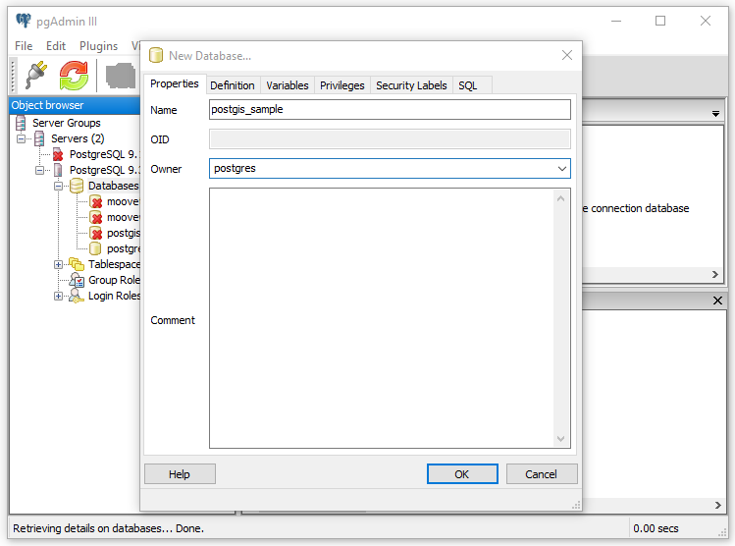

Figure 1 Database Creation

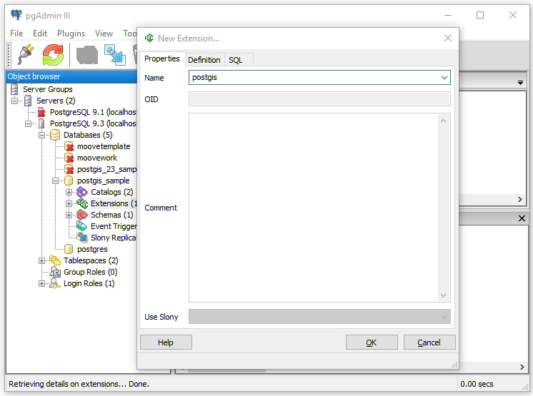

Figure 2 Add Extension

# Using the System

## File Management

Before data generation process, user need to load the floor plan into the system. Press the *Import* button. The system will prompt the file chooser panel for finding floor plan as shown in Figure 3. The system will give successful prompt information after the file loaded to the system. Then, user need to press *Load* button for displaying the parsed floor plan into the system as shown in Figure 4.

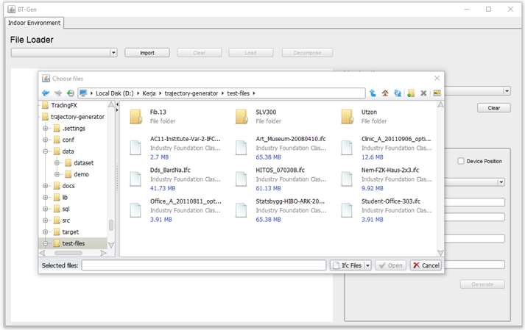

Figure 3 Floor Plan Loader

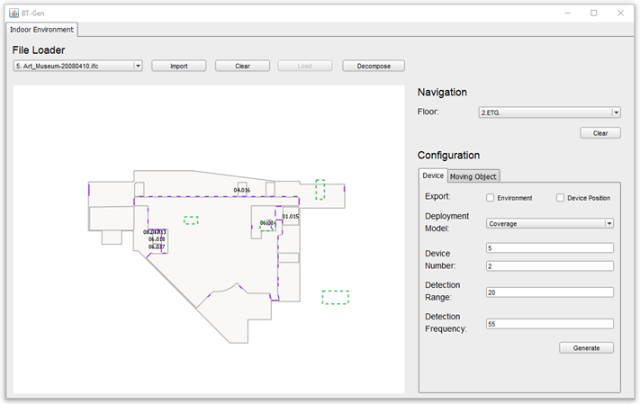

Figure 4 Floor Plan Visualization

## Trajectory Data Generation

In this phase, user configure the device position and settings for data generation. The configuration is shown in Figure 5. There are two external information that can be generated, first is the parsed building information and the second is the device position. After user finish the configuration, user should press *Generate* button to prompt file chooser panel. This panel is used for saving the external information.

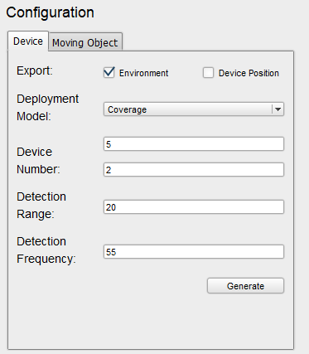

Figure 5 Device Configuration

Next, user need to load the moving object config file that formatted using JSON. The example file is shown in Figure 6.

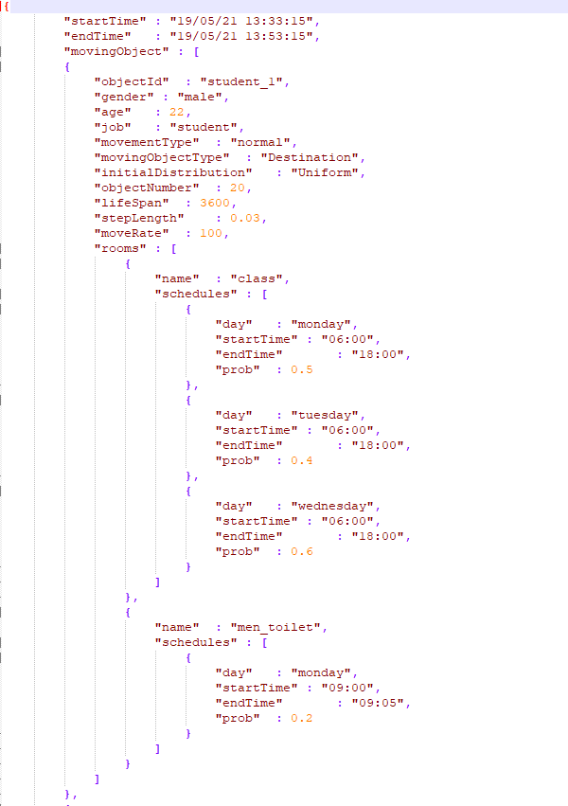

Figure 6 Example of Moving Object Configuration File

Figure 7 show the configuration panel of moving object. After successfully loaded, user will choose either trajectory data or Raw RSSI that will be generated from the system. Then user press *Init* button for placing each moving object in the floor plan. User need to press *Start* button to start data generation process. *Stop* button is used to terminate the generation process. *Capture* button is used for creating a snapshot of the data.

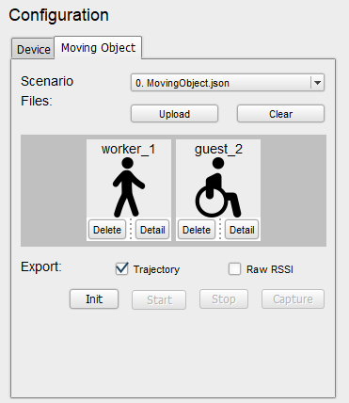

Figure 7 Moving Object Configuration

## Trajectory Visualization

To visualize generated trajectory data, we provide web application to run the application. First, load the trajectory data into the map. Next, check the Trajectory Data checkbox to visualize the movement pattern. To visualize semantics pattern, we can check the Semantic Information checkbox.

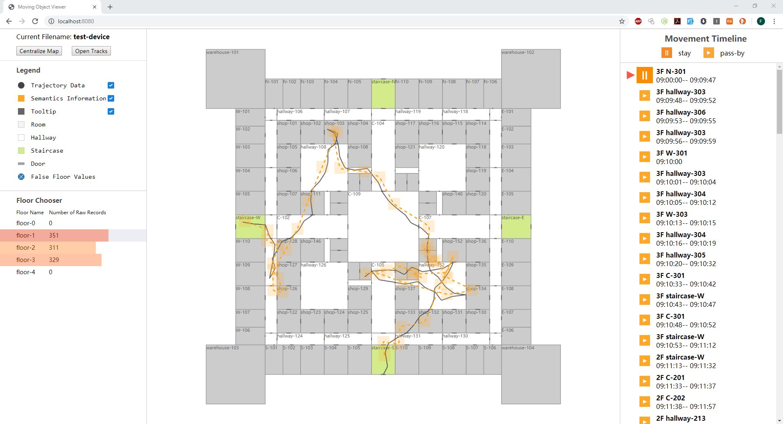

Figure 8 Trajectory Visualization